Software Requirements Specification

for

Hirely
Version 1.0
Prepared by: Team Hirely
FAST NUCES Lahore
Date: 08/02/26
Revision History:
Name | Date | Reason | Version
Team Hirely | [Date] | Initial Draft | 1.0

1. Introduction

1.1 Purpose
This document describes the Software Requirements Specification (SRS) for Hirely, a two-sided recruitment and service marketplace platform.
This SRS defines functional and non-functional requirements for Version 1.0 of Hirely. It serves as a reference for developers, project supervisors, testers, and stakeholders.

1.2 Document Conventions
- “Shall” indicates mandatory requirements.
- “Should” indicates recommended requirements.
- “May” indicates optional requirements.
- Each requirement is uniquely identified as: HR-REQ-x.x
- Priorities: High (H), Medium (M), Low (L)

1.3 Intended Audience and Reading Suggestions
This document is intended for:
- Developers (Frontend & Backend)
- Database Designers
- Project Supervisor
- QA/Testers
- UI/UX Designers
Reading order:
- Introduction
- Overall Description
- External Interface Requirements
- System Features
- Non-functional Requirements
- Appendices

1.4 Product Scope
Hirely is a web-based platform that:
- Filters candidates before job application (AI-based eligibility check)
- Reduces irrelevant job applications
- Allows companies to both hire talent and offer services/products
- Provides real-time application tracking
- Highlights skill gaps before applying
The system improves hiring efficiency, candidate transparency, and recruiter productivity.

1.5 References
- IEEE SRS Template – Karl E. Wiegers
- Hirely Project Proposal
- UML 2.5 Specification – OMG
- React Documentation
- Node.js Documentation

2. Overall Description

2.1 Product Perspective
Hirely is a new standalone web application.
It consists of:
- Frontend (React)
- Backend (Node.js)
- Database (SQL Server)
It interacts with:
- Users (Candidates)
- Companies (Employers)
- Email services (Notifications)

2.2 Product Functions
Major system functions:

Candidate Side
- Register/Login
- Create profile
- Upload CV
- Search jobs
- Apply for jobs
- Pre-application eligibility check
- Track application status
- Browse company services

Company Side
- Register/Login
- Create company profile
- Post jobs/internships
- Manage applicants
- Update application status
- Offer services/products

Use Case Diagram (Figure 1)
Actors:
- Candidate
- Employer
- Admin (optional)
Main Use Cases:
- Register/Login
- Manage Profile
- Post Job
- Apply Job
- Pre-screen Candidate
- Manage Application Status
- Browse Services
Figure 1: Use Case Diagram for Hirely
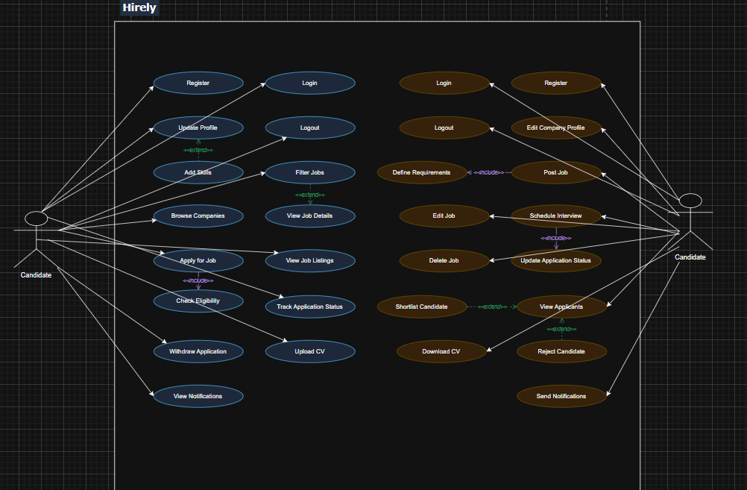
https://app.diagrams.net/?src=about#G1HpDClnii9fGfShT06KDoA_5gAUKevtM2#%7B%22pageId%22%3A%22rc6x9Ej5_7LI9wwSlVqu%22%7D

Context Diagram (DFD Level 0) – Figure 2
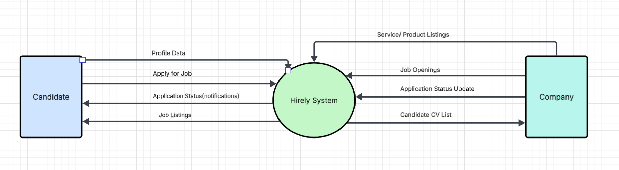
Figure 2: Context Diagram (DFD Level 0) for Hirely
External Entities:
- Candidate
- Company(Employer)
Central Process:
- Hirely System

2.3 User Classes and Characteristics

1. Candidates
- Students or job seekers
- Basic technical skills
- Upload CV
- Apply for jobs
Priority: High

2. Employers
- HR Managers / Recruiters
- Post jobs
- Review applicants
Priority: High
2.4 Operating Environment
- Web Application
- Windows / MacOS
- Chrome, Firefox, Edge
- Backend: Node.js
- Database: SQL Server

2.5 Design and Implementation Constraints
- Must use React (Frontend)
- Must use Node.js (Backend)
- Must use SQL Server
- Secure authentication required
- HTTPS communication

2.6 User Documentation
- User Guide (PDF)
- Admin Manual
- Online Help Section
- FAQ Page

2.7 Assumptions and Dependencies
Assumptions:
- Users provide accurate information.
- Internet connection is available.
Dependencies:
- Email server
- Hosting service
- SQL Server instance

3. External Interface Requirements

3.1 User Interfaces
The Hirely Recruitment Platform provides a graphical user interface (GUI) that enables employers and candidates to interact with the system. The interface has been designed using Figma and follows a clean and consistent layout.The system provides different interfaces for Employers and Candidates.
The following mockups illustrate the Employer-side interface of the platform.
The complete interactive design can be accessed through the following link:
Figma Design Link: https://www.figma.com/design/3ckJYd9rpZTnYAxe1nCEds/Hirely?node-id=3-331&t=8kF3suEtYmnVzK0j-0

Role Selection Screen
The role selection screen allows users to choose whether they want to access the platform as an Employer or a Candidate.
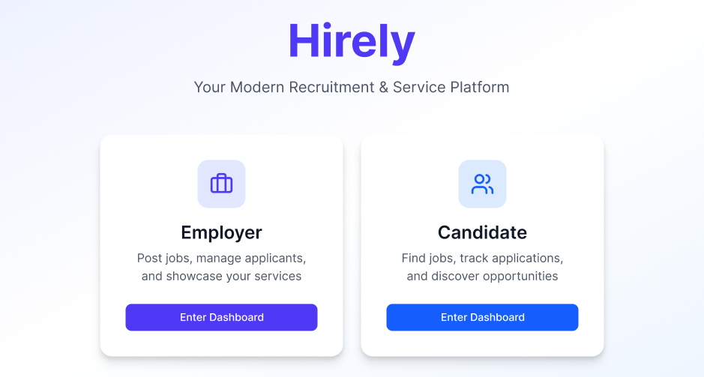
Figure 3.1: Hirely Platform Role Selection Interface

Login/SignUp Screen
This screen allows users to login or sign up the platform as an Employer or a Candidate.
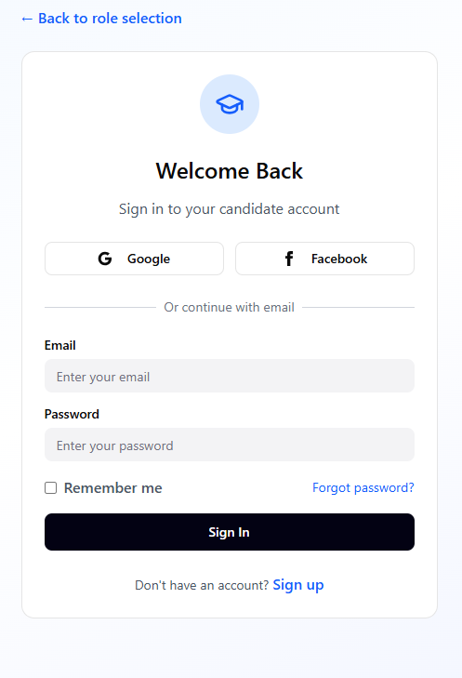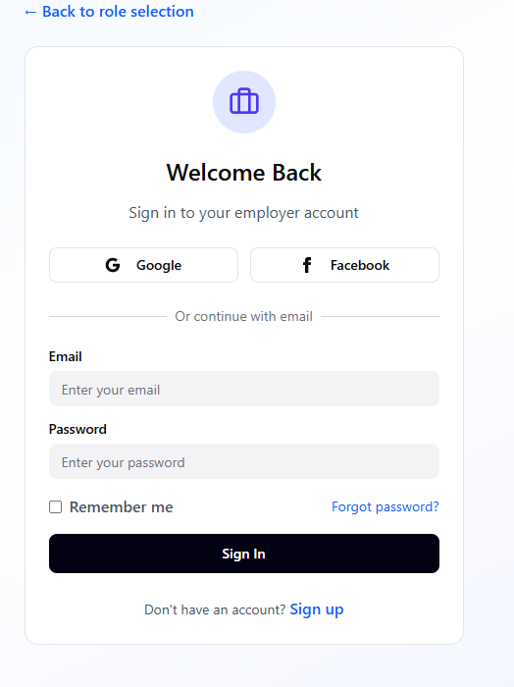
Employer Dashboard
The Employer Dashboard provides an overview of recruitment activity including statistics such as total jobs posted, total applicants, shortlisted candidates, and services listed.
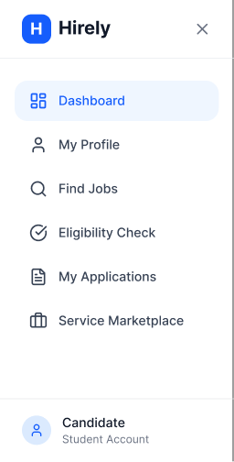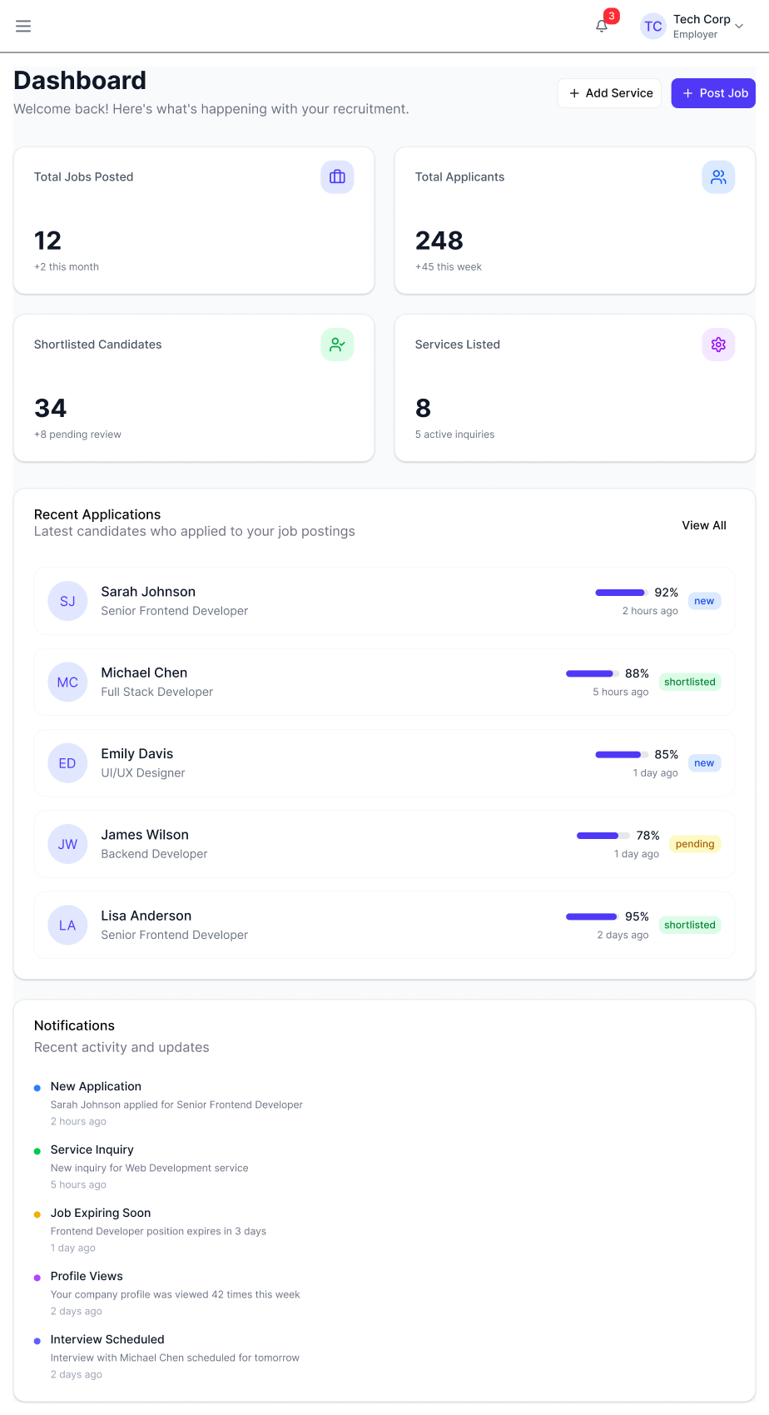
Figure 3.2: Employer Dashboard Interface

Job & Internship Management
This interface allows employers to create, view, edit, and manage job or internship postings.
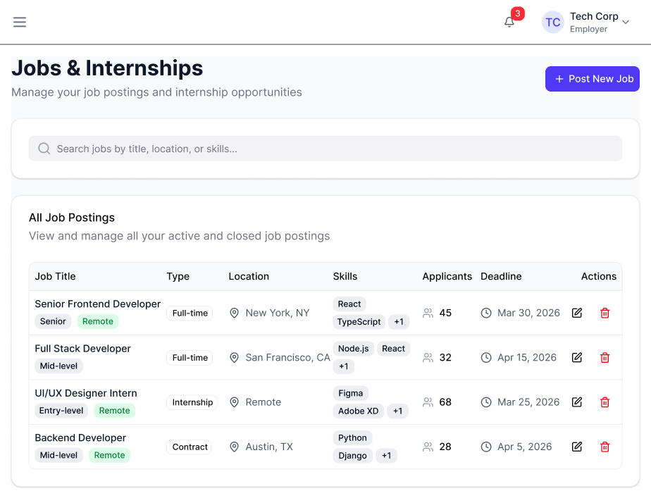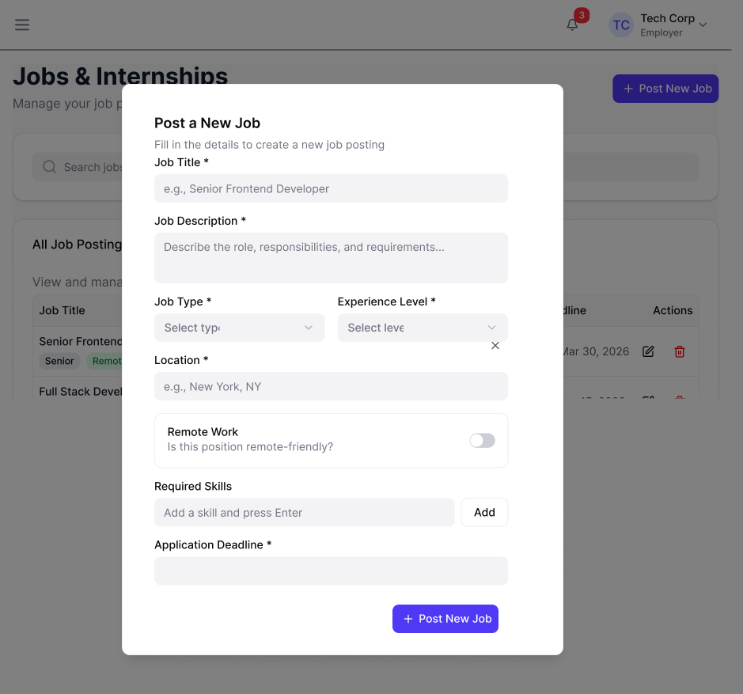
Figure 3.3: Job and Internship Management Interface

Applicant Management
Employers can view applicants who have applied for their job postings. They can review and shortlist suitable candidates. 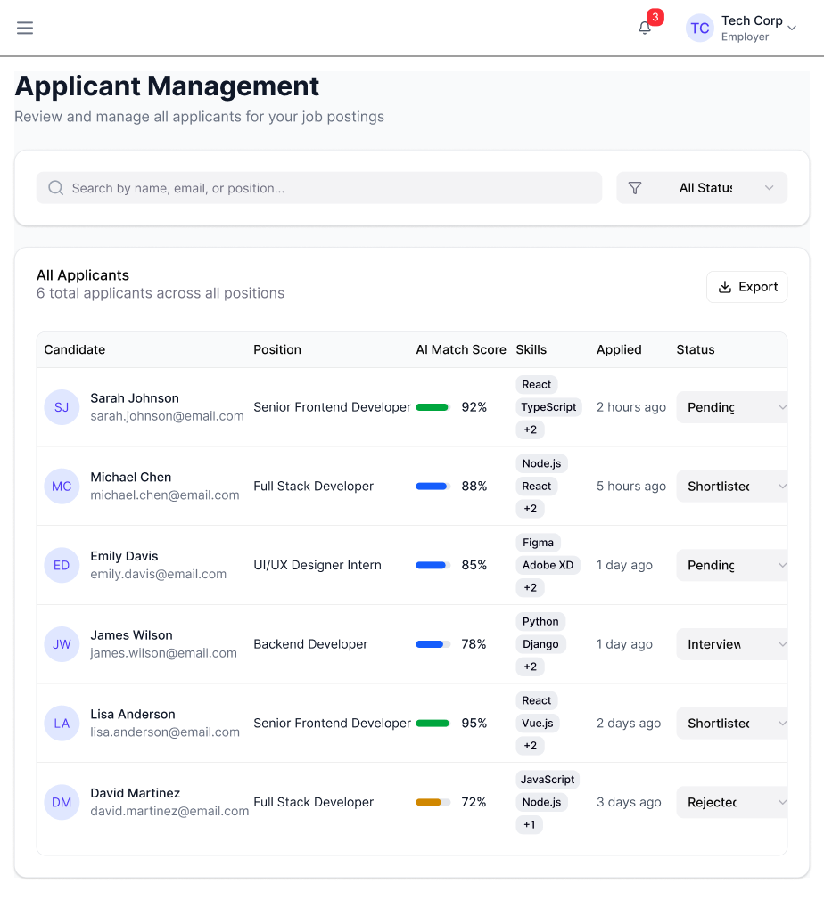
Figure 3.4:Applicant Management Interface

Company Profile Management
This interface allows employers to manage company information including company description, contact information, and other profile details.
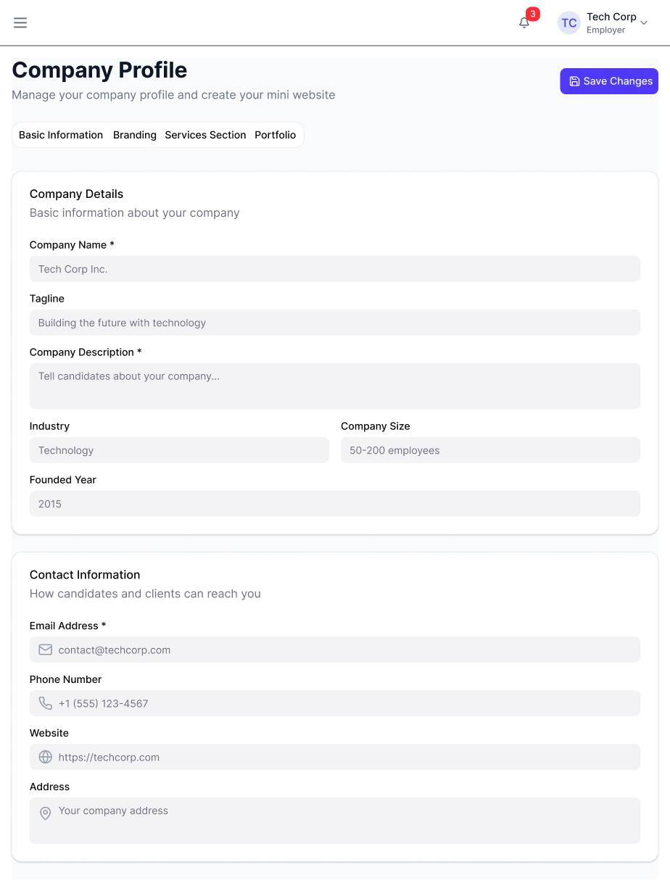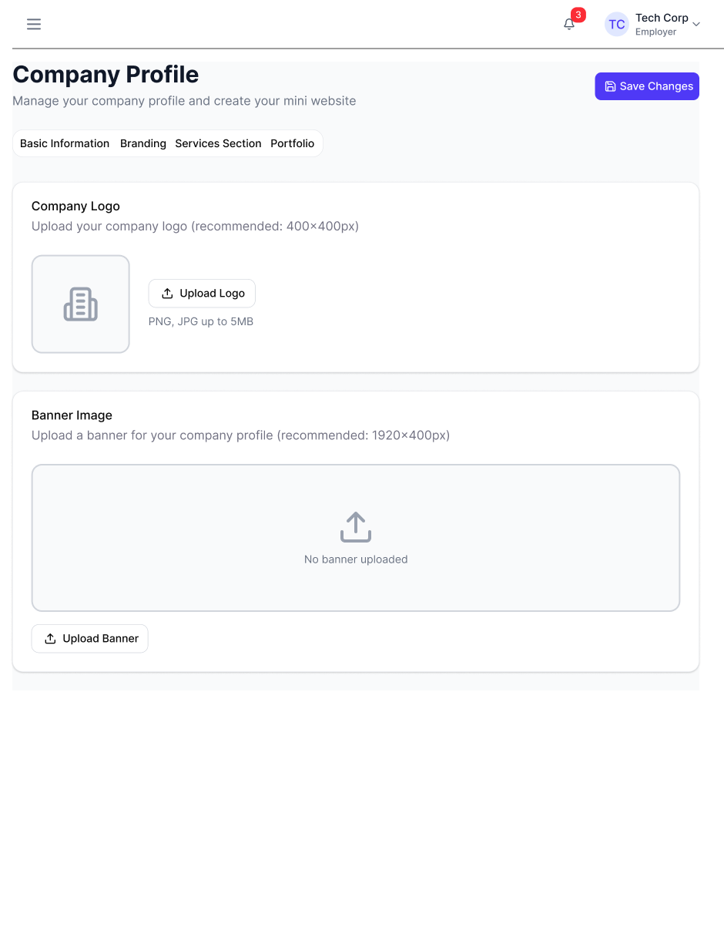
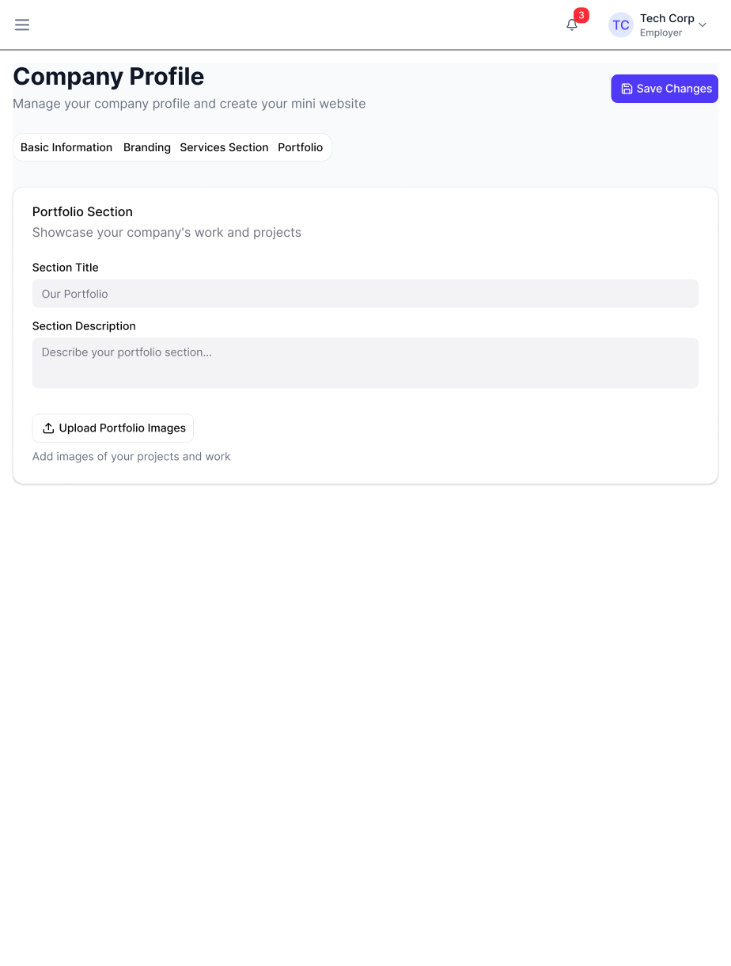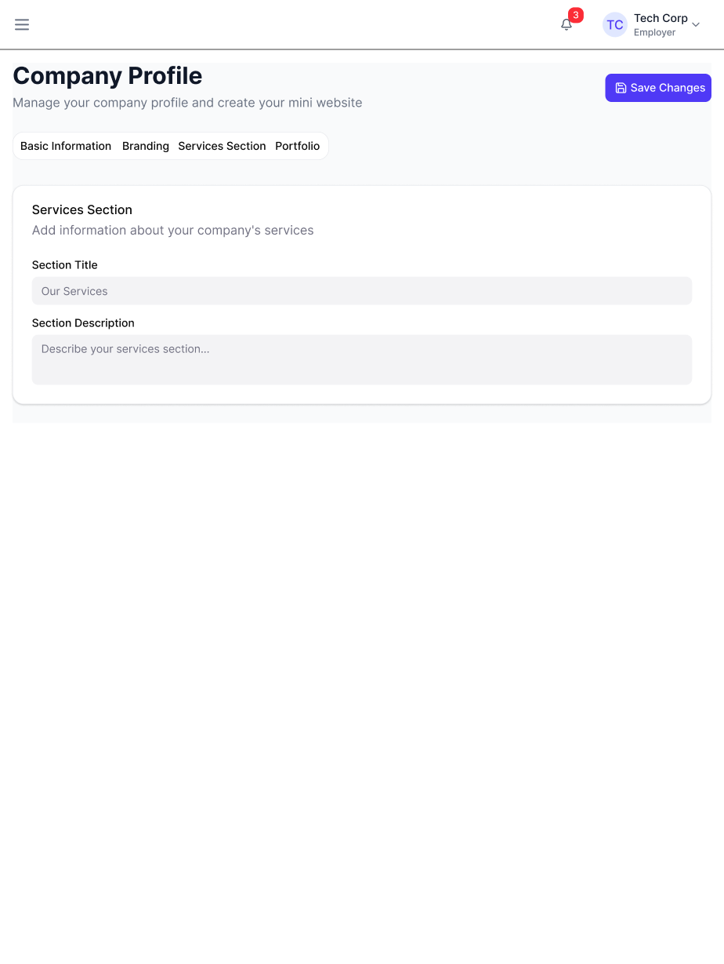
Figure 3.5: Company Profile Interface

Services and Products Management
Employers can add and manage services or products offered by their company.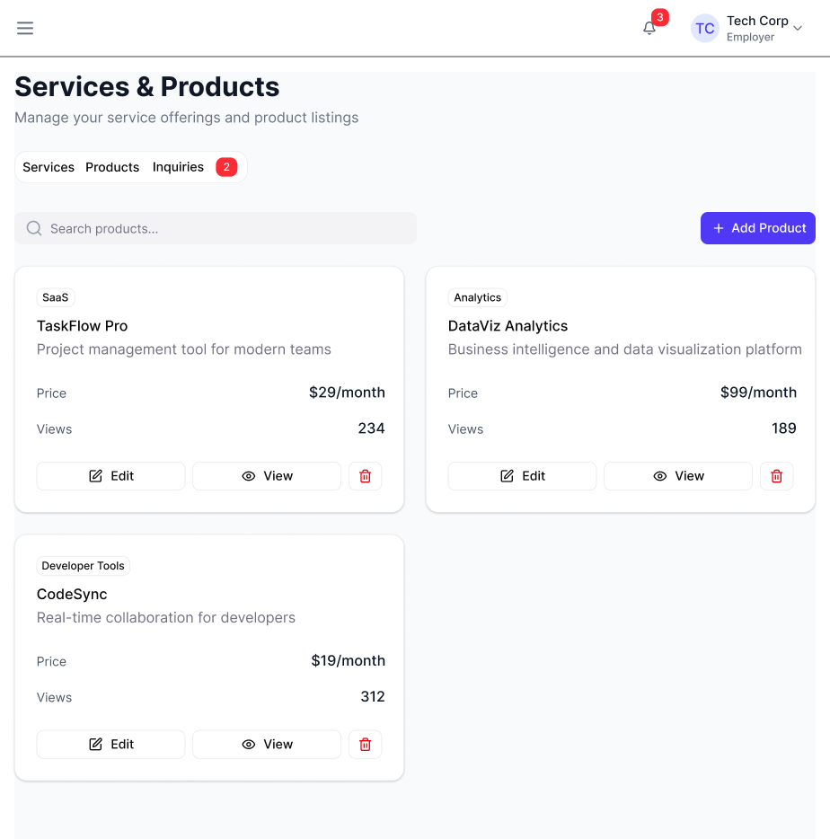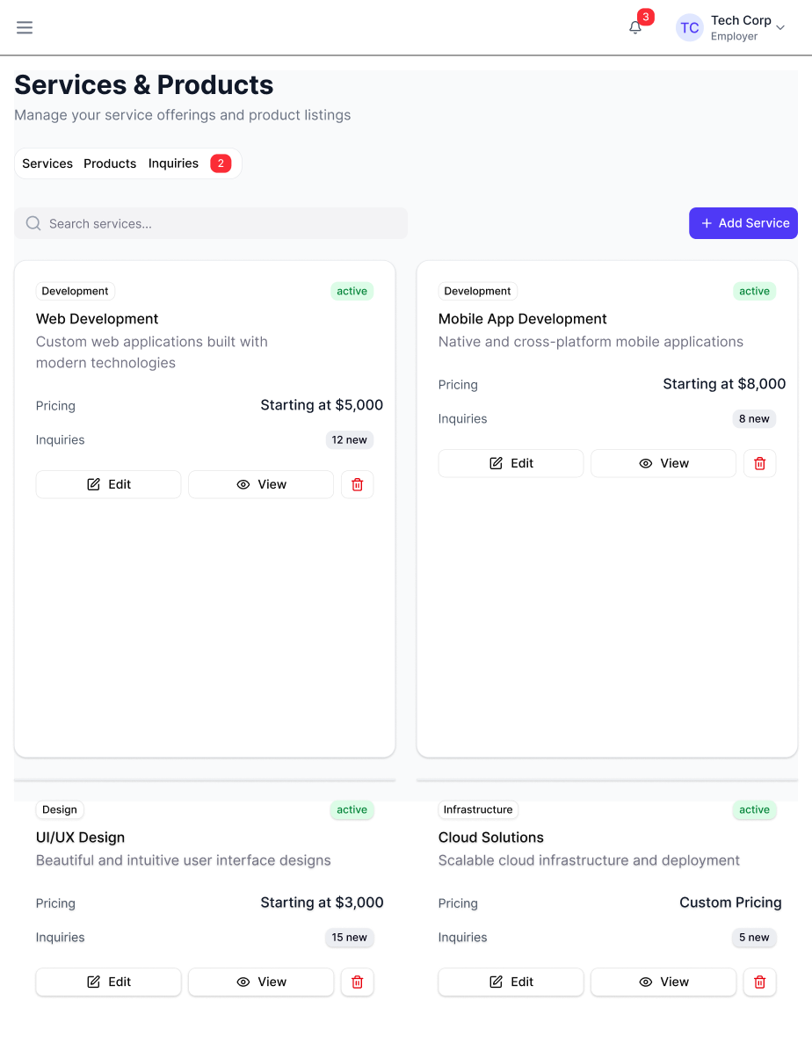 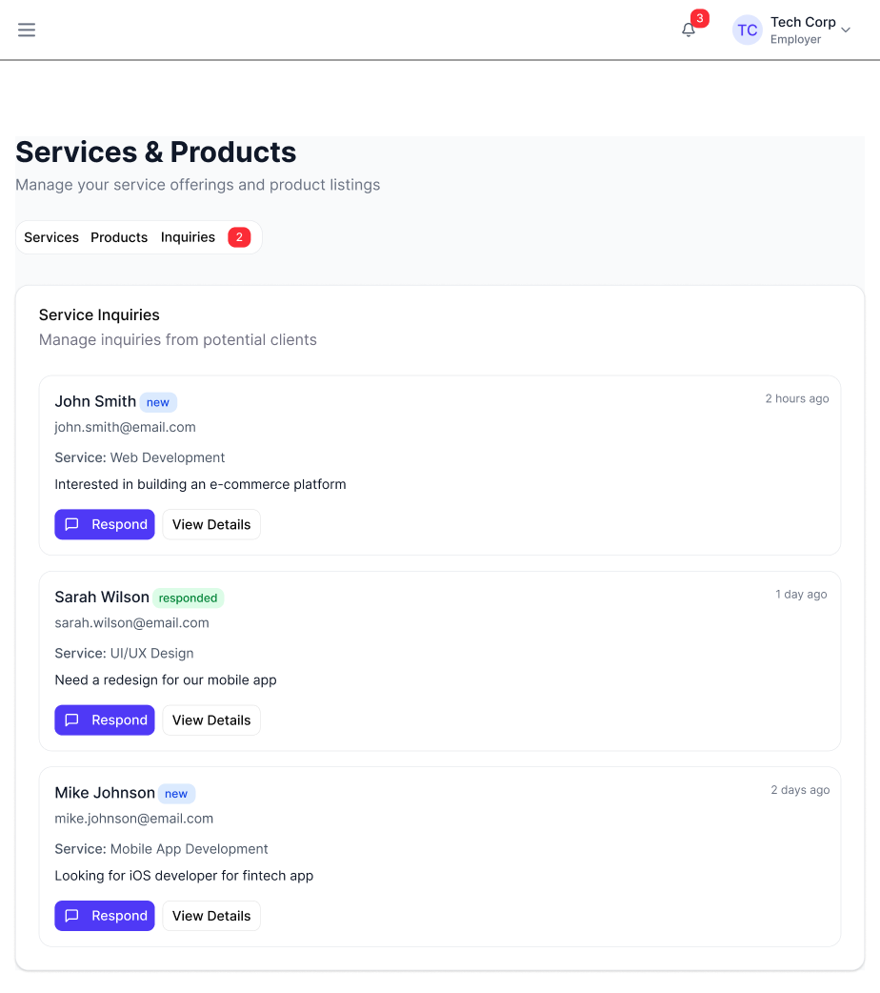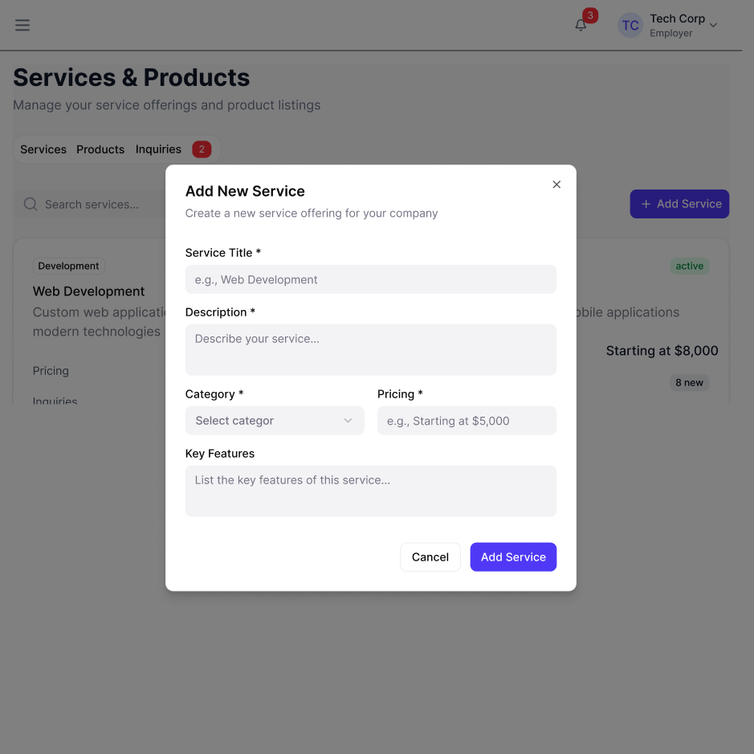Figure 3.6: Services and Products Interface

Candidate Dashboard
The Candidate Dashboard provides an overview of the user’s job search progress. It displays profile completion status, application statistics, recent applications, recommended jobs, and quick actions to help candidates manage their job search efficiently.
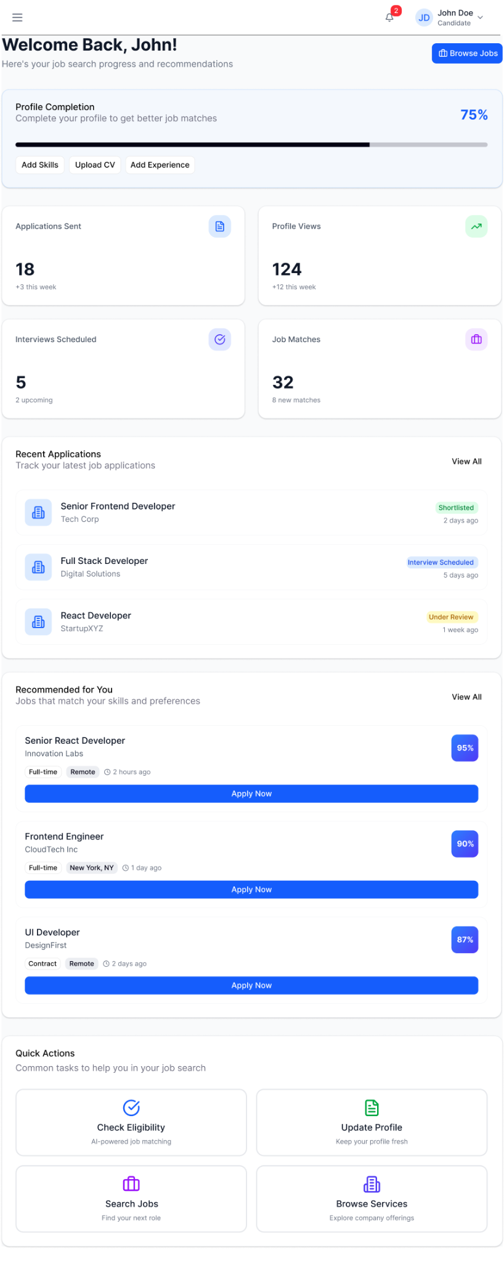
Figure 3.6: Candidate Dashboard of the Hirely Platform.

Candidate Profile
The Candidate Profile screen allows users to manage and update their personal information, skills, experience, education, and resume details.
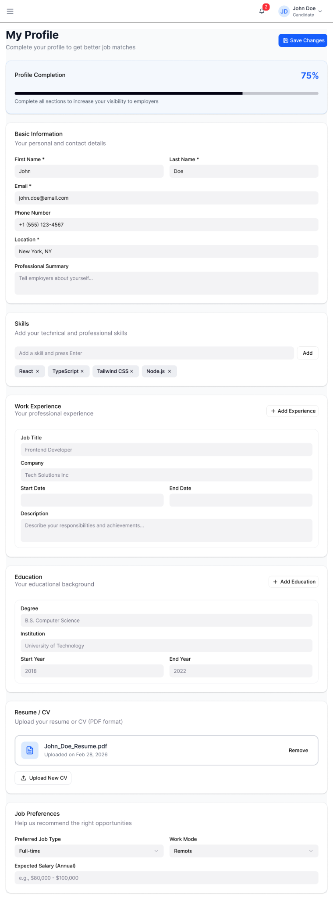
Figure 3.7: Candidate Profile Screen of the Hirely Platform.

Find Jobs
The Find Jobs screen allows candidates to search job opportunities based on their skills, preferences, and job type filters.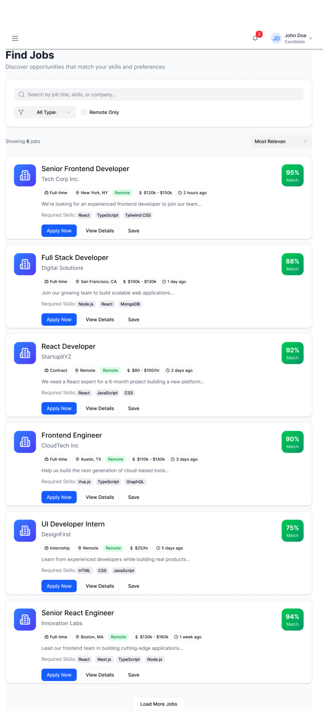
Figure 3.8: Job Search Interface of the Hirely Platform.

Eligibility Check Screen
This screen allows candidates to select a job position and check their eligibility using the AI matching system.

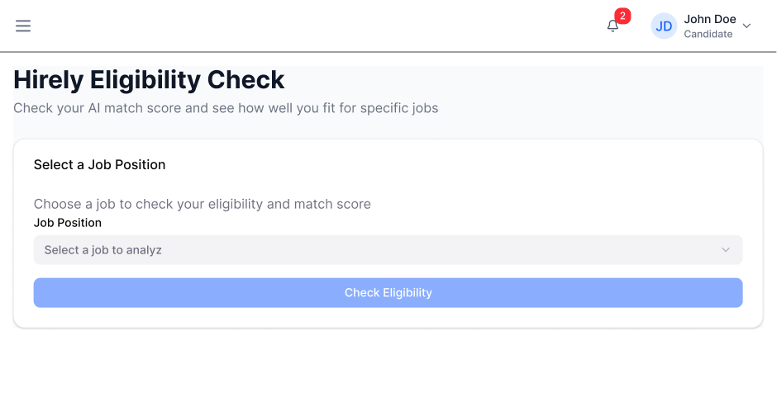Figure 3.9: Eligibility check interface for analyzing candidate–job match score.

My Applications Screen
This screen allows candidates to track the status and progress of all job applications in one place.
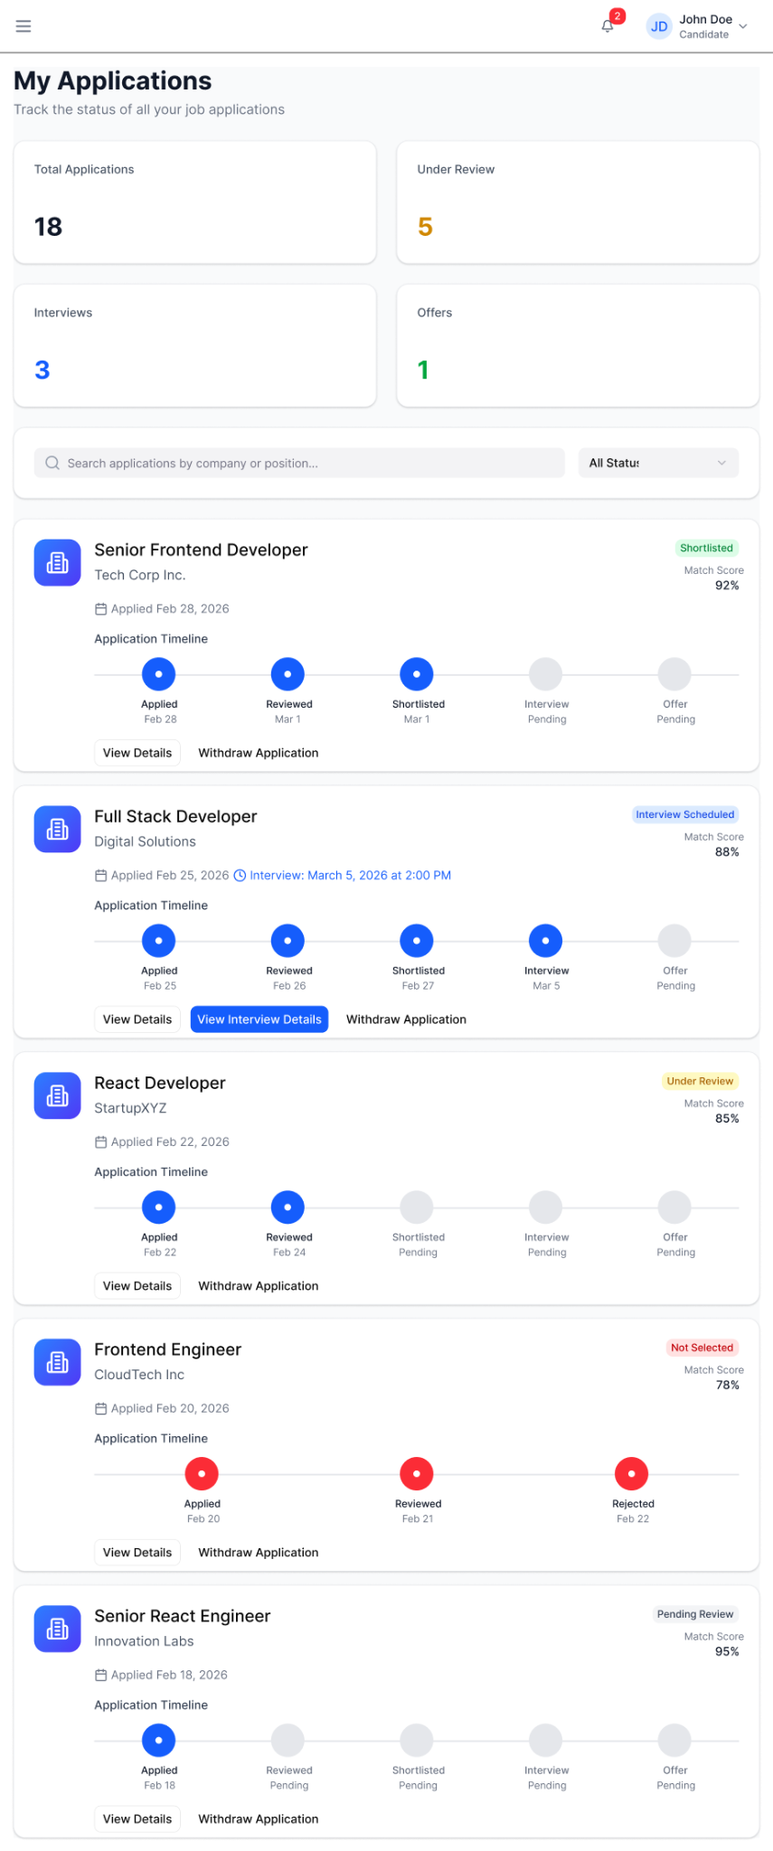
Figure 3.10: My Applications dashboard showing application status, interview updates, and progress timeline.

Service Marketplace Screen

This screen allows candidates to explore different companies, their services, and products available on the platform.
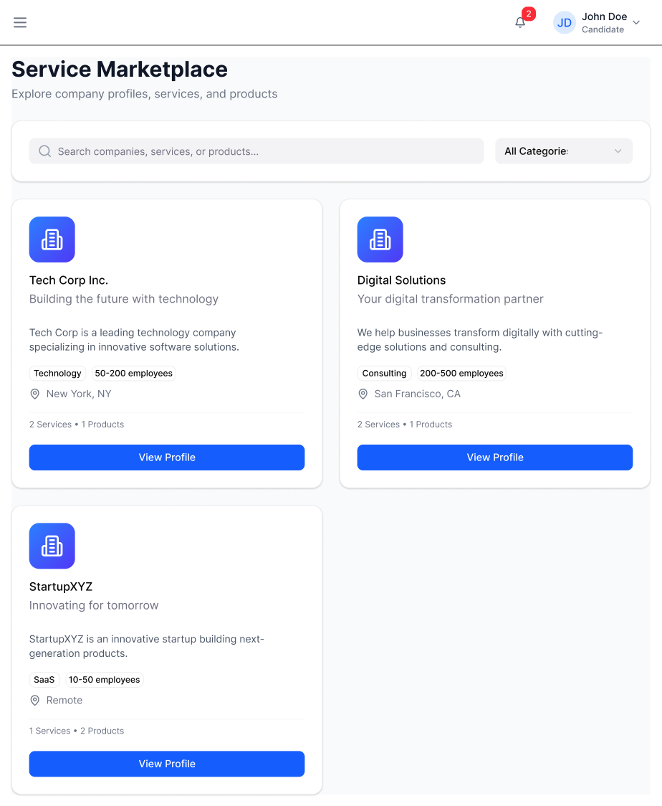

Figure X: Service Marketplace interface displaying company profiles, services, and product information.
UI Standards:
- Responsive design
- Clear navigation
- Minimalist interface
- Error messages in red
- Success messages in green

3.2 Hardware Interfaces
No direct hardware interaction required.
Users require:
- Internet-enabled device
- Keyboard and mouse

3.3 Software Interfaces
- SQL Server Database
- Email Service (SMTP)
- REST APIs

3.4 Communications Interfaces
- HTTP/HTTPS protocol
- Email notifications via SMTP
- Secure authentication tokens (JWT)

4. System Features

4.1 User Authentication

4.1.1 Description and Priority
Allows candidates and employers to register and login.
Priority: High

4.1.2 Stimulus/Response
User enters credentials → System validates → Redirect to dashboard.

4.1.3 Functional Requirements
HR-REQ-1.1: System shall allow users to register.
HR-REQ-1.2: System shall validate email uniqueness.
HR-REQ-1.3: System shall encrypt passwords.
HR-REQ-1.4: System shall allow login with correct credentials.
HR-REQ-1.5: System shall display error for invalid login.

4.2 Job Posting & Management
Priority: High
HR-REQ-2.1: Employer shall post jobs.
HR-REQ-2.2: Employer shall edit jobs.
HR-REQ-2.3: Employer shall delete jobs.
HR-REQ-2.4: Employer shall close job postings.

4.3 Pre-Application Eligibility Check (Hirely AI)
Priority: High
HR-REQ-3.1: System shall compare candidate skills with job requirements.
HR-REQ-3.2: System shall highlight missing skills.
HR-REQ-3.3: System shall block application if mandatory criteria not met.
HR-REQ-3.4: System shall display eligibility percentage.

4.4 Application Management
HR-REQ-4.1: Candidate shall apply for jobs.
HR-REQ-4.2: Employer shall shortlist candidates.
HR-REQ-4.3: Employer shall update status (Accepted, Rejected, Interview).
HR-REQ-4.4: Candidate shall view application status in real time.

4.5 Service Marketplace
HR-REQ-5.1: Company shall list services/products.
HR-REQ-5.2: User shall browse services.
HR-REQ-5.3: User shall send service inquiry.

5. Other Nonfunctional Requirements

5.1 Performance Requirements
- System shall support 1000 concurrent users.
- Page load time < 3 seconds.
- Application status update < 2 seconds.

5.2 Safety Requirements
- No automatic deletion of user data without confirmation.
- Backup system daily.

5.3 Security Requirements
- Password hashing.
- JWT authentication.
- Role-based access control.
- HTTPS communication.
- SQL Injection prevention.

5.4 Software Quality Attributes
- Usability: Easy navigation.
- Reliability: 99% uptime.
- Scalability: Cloud deployable.
- Maintainability: Modular code structure.

5.5 Business Rules
- Only registered employers can post jobs.
- Candidate must complete profile before applying.
- Application deadline enforced.
- Status change visible to candidate immediately.

6. Other Requirements
- Database normalization (3NF).
- Audit logs for status updates.
- Future AI integration support.

Appendix A: Glossary
Term | Meaning
Candidate | Job seeker
Employer | Company
Eligibility Check | Pre-application skill validation
JWT | JSON Web Token
DFD | Data Flow Diagram

Appendix B: Analysis Models
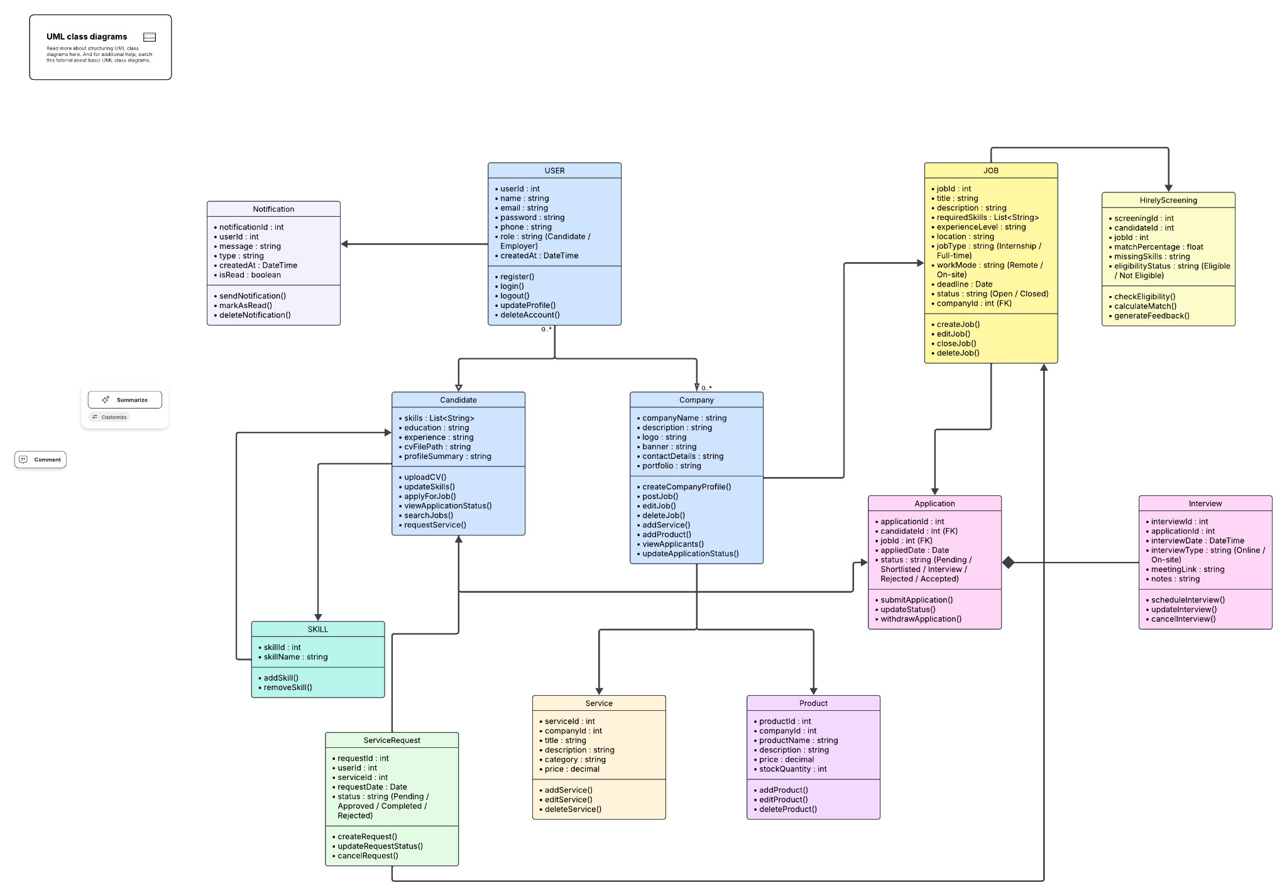Figure B1: Design Class Diagram
- Design Class Diagram
Classes:
- User
- Candidate
- Company(Employer)
- Job
- Application
- Service
- Notification
- HirelyScreeing
- Skill
- Service Request
- Product
- Interview

- DFD Level 1
Processes:
- 1.0 Manage User Profile
- 2.0 Manage Job Listings
- 3.0 Handle Job Applications & Screening
- 4.0 Manage Services / Products
- 5.0 Manage Notifications & Status Updates

Data Stores:
- D1 – User Profiles
- D2 – Job Listings
- D3 – Applications
- D4 – Services / Products
- D5 – Notifications
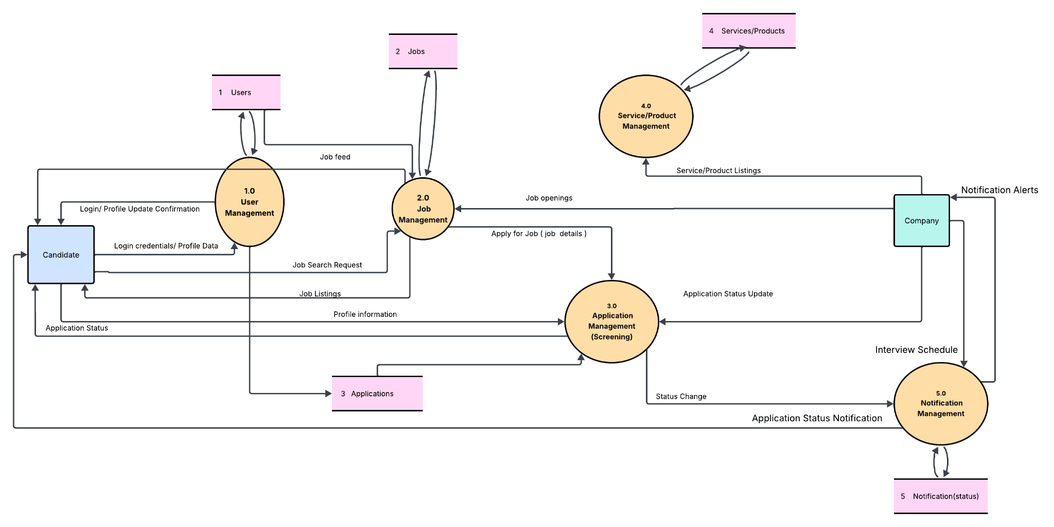
Figure B2: DFD Level 1

Appendix C: To Be Determined List
TBD-1: AI algorithm selection
TBD-2: Cloud hosting provider
TBD-3: Notification integration details

